May 20, 2022

MAISHA SADIA

ID: 18009632

ANDROID REPORT

FOOD DELIVERY APPLICATION

# INTRODUCTION

The aim of this project was to create a Food Delivery Application providing three level access:

1. As a customer
2. As a Restaurant Owner
3. As a Delivery Driver

The motive was to allow the Restaurant Owner to upload their restaurant item into the application with all the details of the item. This includes the image of the food, price, description of the item as well as the quantity of the item available in their store. Later, these uploaded contents will be available to the customer on their screen from where they can select and order the food they want. This process is further propagated to the delivery driver where, according to the location of the customer and the location of the restaurant, they can select if they want to deliver the food or to leave it.

# Application snapshots

## the splash screen

The Splash Screen consists of an animation for the food delivery app icon and the name of the developers to appear one after the other in a sequence. This screen stays on for at least 2 seconds and then redirects the users to the main menu for logging in.



## the main menu

The main menu contains a welcome message with an animated background which zooms in and out simultaneously. This page allows the user to login to the system in three different ways:

1. By inserting their email to login
2. By their phone number
3. Or registering themselves as a new user

This content is wrapped up in a card with a transparent background, which enables the user to see the motion effect of the picture behind the card.

## the user selection screen

After selecting the registration button, it will redirect the user to the select user page, here the user can declare the type of user they want to be in the system, a restaurant owner, customer, or a delivery person. 

## registration screen

Later, after the selection of the user, they are directed to the registration page, where all the details of the user are recorded, verified, and authenticated, then stored in the system.



## login with email screen

Here existing users enter their email and password to log into the system.

## Accessed as a restaurant owner

This screen is showcased when a user enters the system as a restaurant owner. It consists of:

* Home
* Orders Pending
* Orders
* Add a new dish tab

In the home screen, all the dishes available in the restaurant are listed. Orders pending are the orders that have been made by the customers and are pending to be accepted by the restaurant. The orders section consists of the history of the orders and post dish is where a user can post their new dishes on the menu.

## post a new dish

Here a button is available to add a new dish to the menu. The background image is changing every 3 seconds to give an animation effect while the user decides what to upload next onto their menu.

After selecting the post dish button, it takes the user to the uploading dish screen where they can select the dishes, upload an image for the dish and include the description, quantity and the price of the item.

Later, the uploaded item can be edited or deleted from the home screen

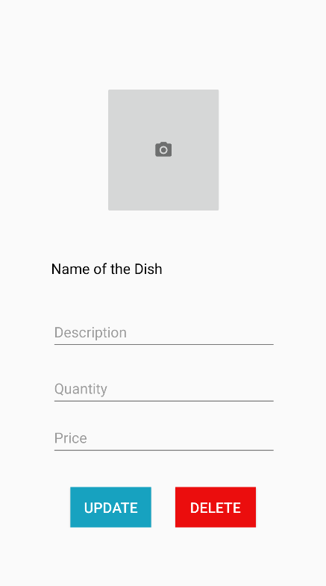

## customer main screen

The main screen of the customer consists of five tabs:

* Home
* Ordered Item
* Previous Orders
* Track Order
* Profile

Here in the home screen, it showcases the restaurants available with the menu details. If a customer adds any item from the menu, it goes to the ordered item screen, then after they have ordered their food, they can track their delivery and any previous orders they have made.

## Delivery Person main screen

The screen of the delivery person only has Pending Orders and Take Orders as shown in the screenshot on the left.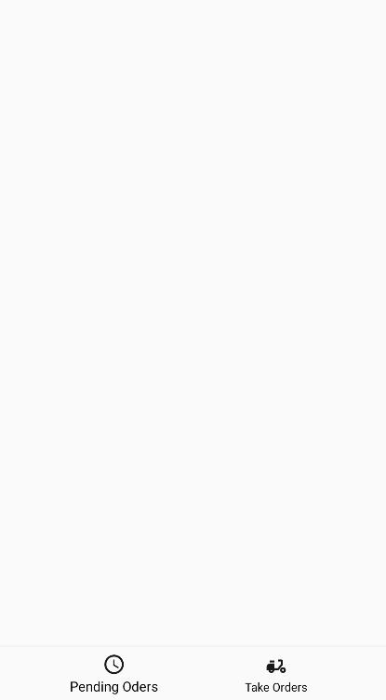

# implementation

## splash screen

The splash screen consists of ImageView and TextView, here the action bar is hidden by declaring the actionbar and implementing actionbar.hide() to hide the action bar giving the full screen view. The image and text items are captured by their id using findViewById in order to perform animation with these views.



This statement allows the text to appear in the screen 1 second after the logo. An event handler was used in order to make the splash screen visible for 2 seconds then redirecting to the main activity screen.

Other than the animation, to automate the login after a user has logged into the system previously, it authenticates and gets their details from firebase giving them direct access to the respective main screen. If the user is new to the system, it will direct the user to the main screen. If their email is not verified then it will display an alert saying the email is not verified, or it will take the user to the Customer/Restaurant/Delivery main screen.

databaseReference = firebaseDatabase.*getInstance*().getReference("User").child(FirebaseAuth.*getInstance*().getUid()+"/Role");  
  
databaseReference.addListenerForSingleValueEvent(new ValueEventListener() {  
 @Override  
 public void onDataChange(@NonNull DataSnapshot snapshot) {  
 String role = snapshot.getValue(String.class);  
  
 if(role.equals("Restaurant")){  
 startActivity(new Intent(SplashScreenActivity.this,RestaurantPanel_BottomNav.class));  
 finish();  
  
 }  
 if(role.equals("Customer")){  
 startActivity(new Intent(SplashScreenActivity.this,CustomerPanel_BottomNav.class));  
 finish();  
  
 }  
 if(role.equals("DeliveryPerson")) {  
 startActivity(new Intent(SplashScreenActivity.this, DeliveryGuyPanel_BottomNav.class));  
 finish();  
 }  
 }  
  
 @Override  
 public void onCancelled(@NonNull DatabaseError error) {  
 Toast.*makeText*(SplashScreenActivity.this,error.getMessage(),Toast.*LENGTH_LONG*).show();  
 }  
});

## registration and firebase

All the data entered in the registration area is captured by an ID number. After the register button is pressed, the setOnClickListener function is started, which first checks if there is any missing information in the registration form and the data entered is valid by running the isValid function. If it passes these functions, then it launches a please wait dialogue. While this message is displayed to the user, the user details are stored into a HashMap as key-value pairs. This HashMap is passed into the firebase database, which creates a user in the firebase along with a table containing the role of the user, and a table which consists of all the user details.

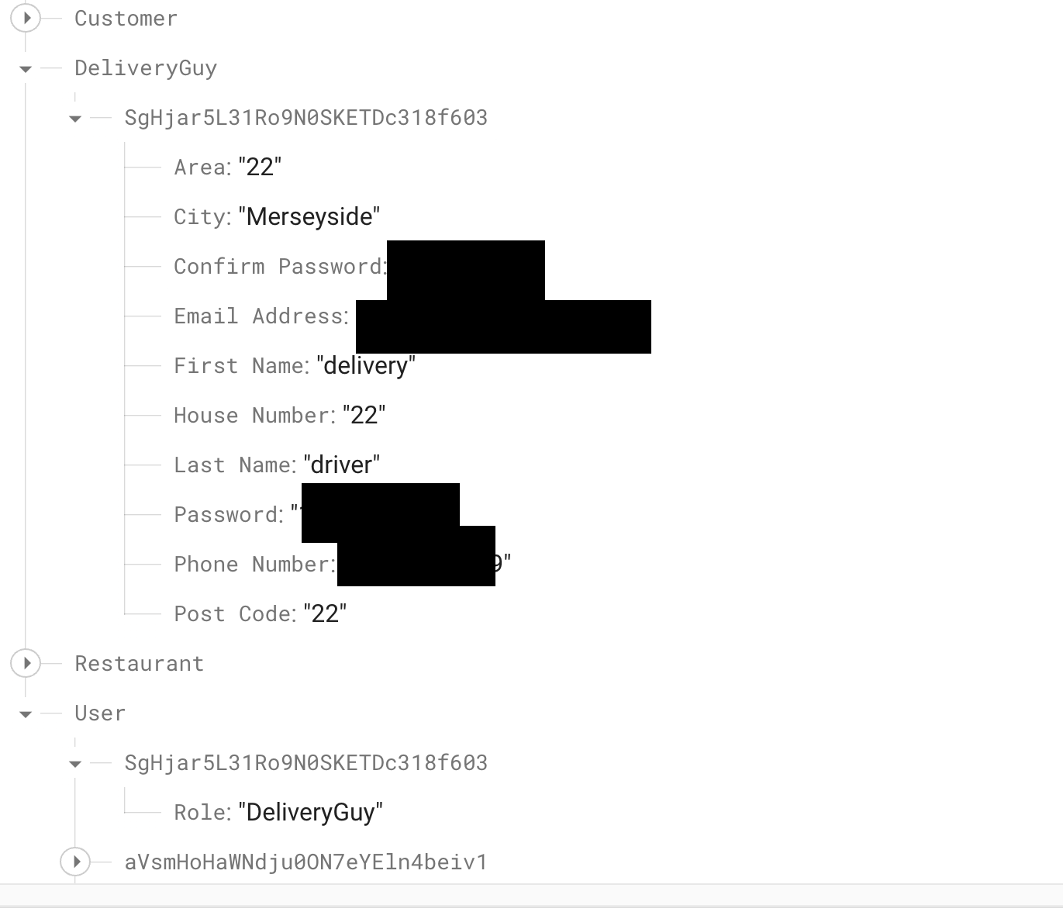

The figure above demonstrates how the data is arranged and stored in the database. It was stored in this manner so that the role of the user can be easily identified and then redirected to the corresponding role table to extract the information.

## Main menu implementation

The main menu or the action bar for each user type was done by breaking down each screen into fragments. In the resource folder a menu package was created where all the menu items along with their icons were generated inside a menu tag. Later, an activity panel for the action bar was created where Relative Layout was used. Inside the layout, a frame layout was introduced which consists of the menu item, this was done by the help of a google.android material for the view of the action bar.

<RelativeLayout xmlns:android="http://schemas.android.com/apk/res/android"  
 xmlns:app="http://schemas.android.com/apk/res-auto"  
 xmlns:tools="http://schemas.android.com/tools"  
 android:layout_width="match_parent"  
 android:layout_height="match_parent"  
 tools:context=".DeliveryGuyPanel_BottomNav">  
  
 <FrameLayout  
 android:id="@+id/fragment_container2"  
 android:layout_width="match_parent"  
 android:layout_height="match_parent">  
  
 <com.google.android.material.bottomnavigation.BottomNavigationView  
 android:id="@+id/cus_bottom_nav"  
 android:layout_width="match_parent"  
 android:layout_height="wrap_content"  
 android:layout_gravity="bottom"  
 android:background="?android:attr/windowBackground"  
 android:backgroundTint="@color/white"  
 app:itemIconTint="@color/Black"  
 app:itemTextColor="@color/Black"  
 app:layout_constraintBottom_toBottomOf="parent"  
 app:menu="@menu/delivery_bottom_nav" />  
 </FrameLayout>  
  
</RelativeLayout>

As mentioned earlier, each screen was broken into fragments. The selection of each button on the fragment was passed along, allowing the transition between the screens.

public boolean onNavigationItemSelected(@NonNull MenuItem item) {  
 Fragment fragment = null;  
 switch (item.getItemId()){  
 case R.id.*restaurantHome*:  
 fragment=new RestaurantHomeFragment();  
 break;  
 case R.id.*restaurantProfile*:  
 fragment=new RestaurantProfileFragment();  
 break;  
 case R.id.*restaurantOrder*:  
 fragment=new RestaurantOrderFragment();  
 break;  
 case R.id.*restaurantPendingOrder*:  
 fragment=new RestaurantPendingOrdersFragment();  
 break;  
  
 }  
 return loadResFragment(fragment);  
}

private boolean loadResFragment(Fragment fragment) {  
 if(fragment != null){  
 getSupportFragmentManager().beginTransaction().replace(R.id.*fragment_container1*,fragment).commit();  
 return true;  
 }  
 return false;  
}

## uploading dish

Uploading a dish was done in a similar way as registering a user. The only difference this time was that an image is also uploaded. After selecting an image it allows the user to crop the image according to their need with the help of CropImage.startPickImageAcrivity(this). After verifying all the menu details, by checking for any missing values, it then starts to uploadImage. Here onProgress listener was implemented to get the percentage of uploaded by calculating the progress.

public void onProgress(@NonNull UploadTask.TaskSnapshot taskSnapshot) {  
 double progress = (100.0*taskSnapshot.getBytesTransferred()/taskSnapshot.getTotalByteCount());  
 progressDialog.setMessage("Uploaded "+(int) progress+"%");  
 progressDialog.setCanceledOnTouchOutside(false);  
}

## Restaurant and customer home screen

For both the customer and restaurant home screen, recycler view was used. On the restaurant home screen, a restaurantHomeAdapter was used to hold the menu items. A similar concept was applied for the customer home screen.

DatabaseReference databaseReference = FirebaseDatabase.*getInstance*().getReference("Food_Details").child(City).child(Area).child(useridd);  
databaseReference.addValueEventListener(new ValueEventListener() {  
 @Override  
 public void onDataChange(@NonNull DataSnapshot snapshot) {  
 updateDishModelList.clear();  
 for(DataSnapshot snapshot1:snapshot.getChildren()){  
 UpdateDish updateDishModel = snapshot1.getValue(UpdateDish.class);  
 updateDishModelList.add(updateDishModel);  
 }  
 adapter = new RestaurantHomeAdapter(getContext(),updateDishModelList);  
 recyclerView.setAdapter(adapter);  
 }  
  
 @Override  
 public void onCancelled(@NonNull DatabaseError error) {  
  
 }  
});

Here, the data consisting of the menu items is collected and then displayed in the recycler view.

## updating a dish

Updating a dish is done first by getting the information stored in the database. This allows the user to edit the details of the dish and after the update button is pressed, a setOnClickListener is used for detecting the action which allows to update the data in the database and then later redirects the user to the main menu. Conversely, for the delete action it gives an alert to the user if they actually want to delete the item. If confirmed, it removes the item from the database after matching the details of the item with the data present in Food_Details table.

AlertDialog.Builder builder = new AlertDialog.Builder(activity_update_delete_dish.this);  
builder.setMessage("Are you sure you want to Delete Dish");  
builder.setPositiveButton("Yes", new DialogInterface.OnClickListener() {  
 @Override  
 public void onClick(DialogInterface dialog, int which) {  
 firebaseDatabase.*getInstance*().getReference("Food_Details").child(City).child(Area)  
 .child(FirebaseAuth.*getInstance*().getCurrentUser().getUid()).removeValue();  
 AlertDialog.Builder food = new AlertDialog.Builder(activity_update_delete_dish.this);  
 food.setMessage("Your Dish Has Been Deleted!");  
 food.setPositiveButton("OK", new DialogInterface.OnClickListener() {  
 @Override  
 public void onClick(DialogInterface dialog, int which) {  
 startActivity(new Intent(activity_update_delete_dish.this, RestaurantPanel_BottomNav.class));  
 }  
 });  
 AlertDialog alert = food.create();  
 alert.show();

## Customised alert box

In order to explore the area of reusable fragments, an alert dialogue box was generated which could be called by any screen to display the alert that is passed by the components.

public class AlertDialogueBox {  
  
 public static void showAlert(Context context,String title, String message){  
  
 AlertDialog.Builder builder = new AlertDialog.Builder(context);  
 builder.setCancelable(false);  
 builder.setPositiveButton("Ok", new DialogInterface.OnClickListener() {  
 @Override  
 public void onClick(DialogInterface dialogInterface, int i) {  
 dialogInterface.dismiss();  
 }  
 }).setTitle(title).setMessage(message).show();  
 }  
}

## ANIMATIONS

The animation effect present in the main menu was done setting an animation event listener to the background image allowing the user to observe continuous motion of the image in the application

final Animation ZoomIn = AnimationUtils.*loadAnimation*(this, R.anim.*zoom_in*);  
final Animation ZoomOut = AnimationUtils.*loadAnimation*(this, R.anim.*zoom_out*);  
  
bgImage = findViewById(R.id.*bgImage*);  
bgImage.setAnimation(ZoomIn);  
bgImage.setAnimation(ZoomOut);  
  
ZoomOut.setAnimationListener(new Animation.AnimationListener() {  
 @Override  
 public void onAnimationStart(Animation animation) {  
  
 }  
  
 @Override  
 public void onAnimationEnd(Animation animation) {  
 bgImage.setAnimation(ZoomIn);  
  
 }  
  
 @Override  
 public void onAnimationRepeat(Animation animation) {  
  
 }  
});  
  
ZoomIn.setAnimationListener(new Animation.AnimationListener() {  
 @Override  
 public void onAnimationStart(Animation animation) {  
  
 }  
  
 @Override  
 public void onAnimationEnd(Animation animation) {  
 bgImage.setAnimation(ZoomOut);  
 }  
  
 @Override  
 public void onAnimationRepeat(Animation animation) {  
  
 }  
});

For the post dish screen animation drawable was used where 5 different images of food was passed and the image was changed in every 3 seconds.

AnimationDrawable animationDrawable = new AnimationDrawable();  
animationDrawable.addFrame(getResources().getDrawable(R.drawable.*bg_image*),3000);  
animationDrawable.addFrame(getResources().getDrawable(R.drawable.*chips_image*),3000);  
animationDrawable.addFrame(getResources().getDrawable(R.drawable.*starting_bg_image*),3000);  
animationDrawable.addFrame(getResources().getDrawable(R.drawable.*burger_image*),3000);  
  
animationDrawable.setOneShot(false);  
animationDrawable.setEnterFadeDuration(850);  
animationDrawable.setExitFadeDuration(1600);  
  
backGroundImage = view.findViewById(R.id.*res_home_bg*);  
backGroundImage.setBackgroundDrawable(animationDrawable);  
animationDrawable.start();

# conclusion

This focus of this project was to explore all the possibilities available for a user to interact with the application. Although this project is incomplete, it has the potential to be adjusted and restructured into a workable piece of app. For the future of the application, google maps can be implemented to track the driver position to deliver the food, along with many other features that can be introduced such as notification alerts, messaging service etc.